Angels Performing Arts
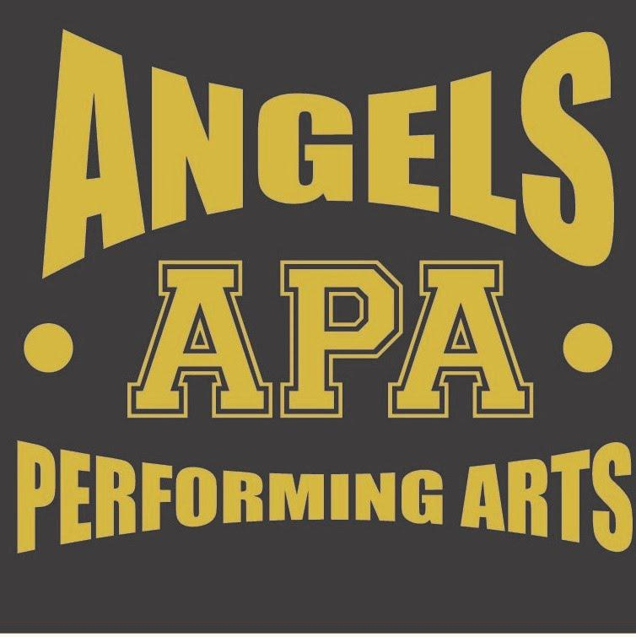
Angels Office
3 Queen Elizabeth Close
Didcot
OX11 8TU

Summer Term Stage School Information Pack

Many thanks for your interest in joining Angels Performing Arts est 2010
Requirements: Saturday only, snack and drink (We are a No Nuts School )

The SCHOOL uniform is compulsory, a vest top, leggings, hoodie (optional) crop top for older girls and jazz shoes, ACRO uniform is acro shorts and crop top, all to be ordered directly through our website at www.angelsperformingarts.co.uk (This is compulsory). Within the few weeks it takes to arrive please wear plain black to class.

Registration will start 2 minutes before the stated class time, so please allow at least 5 minutes getting your child settled in. No parents are permitted to stay on site.

Term Dates Monday25th April – Saturday 16th July 2022

All classes are held at St Birinus School, Mereland Road, Didcot, OX11 8AZ

If you have any questions, please do not hesitate to contact us.

We look forward to seeing you.

J Featherstone

Jennie Featherstone
School Principal

Fees and Payment information

DANCE/ACRO Thursday, Friday,Saturday 2-18 years (£6.25 per class)

Saturday Morning School 3+ years
1.5 hours 10am-11:30pm Singing, Dance & Drama (3 classes £12.50)

Saturday Morning School 5+ years (£6.25 per class)
2.5 hours 10am-12:30pm Singing, Dance & Drama (3 classes £18.75)

Thursday School – St Birinus School, Mereland Road

5.00-5.45pm – Acro Beginners
5.45-6.30pm- Acro Intermediate/Advance

Friday School – St Birinus School, Mereland Road

3:45pm-4:25pm - Dance Beginners

4:35pm-5:25pm for - Dance Intermediate

5:30pm-6:15pm for - Dance Advance

Saturday School Didcot – St Birinus School, Mereland Road

10am -10:45am - Contemporary/Modern Dance

10am -10:45am - Singing

10am -10:45am - Drama/Acting/Musical Theatre

Saturday School Didcot – St Birinus School, Mereland Road

10:45am -11.30am - Drama/Acting/Musical Theatre

10:45am -11.30am - Contemporary/Modern Dance

10:45am -11.30am– Singing

Saturday School Didcot – St Birinus School, Mereland Road

11:45am -12:30pm– Singing

11:45am -12:30pm - Drama/Acting/Musical Theatre

11:45am -12:30pm - Contemporary/Modern Dance

Saturday Acro – St Birinus School, Mereland Road

1pm -1:45pm Beginners

Competition Squads Audition Only.

Once application is completed we will send a invoice for payment, we require Payment in advance or The 4 monthly instalment dates on your invoice or a £4 admin fee will occur.

Private and Confidential

Registration and Permission Form - Child under 18

Child’s Name:________________________________ Age:________Date of Birth:__________________

Address:________________________________________________________________________

Postcode_________________________Contact Tel: ______________________________________

Any known medical conditions/allergies: _______________________Any medication:___________________

Diabetes – Asthma - Epilepsy – Autism – low self esteem – hearing or sight difficulties

Any Special Needs/other important information: ___________________________________________

Please give details of any other training or arts experience____________________________________

___________________________________________________________________________________

Please give details here of any further information you think may be helpful.

Name of Primary / Secondary school: _________________________________

Parent/Guardians Contact email: ________________________________________________________

Mobile: ___________________________________________

In an emergency, please contact:

Parent/Guardian Name: ___________________________Relationship to child___________________

Parent/Guardian Signature: ___________________________________ Date: _____________________

Where did you hear about us? WEBSITE ~ GOOGLE~ SCHOOL~ LEAFLET~ POSTER ~ FRIEND - FACEBOOK

Referred by an existing “Angels” Pupil Name

Date of Registered pupil details on school database –OFFICE USE ONLY

Enrolment CONTRACT between “Angels Performing Arts” and Parent/Guardian

Please read and tick the additional terms and condition options

I give permission for my child to have their photo/video taken for the purposes of the School’s promotional material, marketing and website.

I would be interested in finding out more information about the Holiday Workshops or other classes. – you will be contacted via email or facebook

- We take data protection very seriously at our Stage School, therefore all the data included on these forms will be dealt with according to the “GDPR” by the school and principle.

- Parents are not permitted to watch after the first class or be on the site during class times.

- For all Classes, we require 6 weeks’ notice at half term in writing if your child intends to leave Angels Performing Arts and fees will still need to be paid until the notice is served.

- I understand that all classes in the term will be payable, including missed classes due to holiday or sickness to save your child’s place.

Declaration By Parent/Guardian

Parent Name: _________________________________________ Phone: ______________________________

Parent/Guardian Signature: ___________________________________ Date: _____________________

I enclose a one off £25 registration fee ___ _______________

Total payment enclosed today of £___________. By Cash/Cheque /BACS – reference pupil name

Cheques payable to: Angels Performing Arts BACS: LLOYDS BANK Bank Account: 37647168 Sort code:30-91-91 (DISCOUNT CODE or VOUCHER USED:_____________)

Office use only:

Registered pupil details system Starting date……………………. Waiting list for class

Sibling of …………………… Uniform ordered other__________________

